**Table of Contents**

Table of Contents 1

List of Abbreviations 3

Chapter-1: Introduction 4

1.1 Need for Bi-Directional Converters (BDC) 4

1.2. Load Demand and BDC overview 4

1.3. BDC advantages 5

1.4 Overall Bidirectional converter block diagram 6

Chapter-2: Methodology 7

2.1 Stand Alone Inverter Mode 8

2.2 Grid Tied Inverter Mode 8

2.3 Grid Tied Rectifier Mode 8

2.4 Grid Tied Charger Mode 8

Chapter-3: Hardware Implementation of Single Phase Bidirectional Converter 9

3.1 Power Circuit 9

3.1.1 Snubber Circuit 10

3.1.2 Pulse Amplification and Isolation Circuit 10

3.2 Control Circuits 11

3.2.1 Voltage sensing circuit 11

3.2.2 SPWM Pulses Generation Module 12

3.2.3 Current Sensing Circuit 15

3.2.4 PI Controller Circuit (Analog) 16

3.3 Power Supplies 17

Chapter-4: Experimental Setup and Results 19

4.1 Hardware Design 20

4.2 Hardware Layout 20

4.3 Gate driver 21

4.4 Test Setup 21

4.5 Control Strategy (Carrier based Modulation) 21

4.5.1 Carrier Waveform 21

4.6.2 Reference Waveform 23

4.7 THD and efficiency 24

4.8 Expected Results 25

4.8.1 Stand-alone Inverter Mode 25

4.9 Results 25

4.9.1 Stand-alone Inverter Mode 25

4.9.2 PWM Waveform 26

4.9.3 Voltage Sensor Module 26

Chapter-5: Conclusion and Future Scope 27

5.1 Contribution and Conclusion 27

5.2 Future Work 27

References 28

APPENDIX-A 29

APPENDIX-B 32

# 

**List of Abbreviations**

AC: Alternating Current

BDC: Bi-Directional Converters

C: Capacitance

CMOS:

DC: Direct Current

DER: Distributed Energy Resources

DG: Distributed Generation

Hz: hertz

IC: Integrated Circuit

IEEE: Institute of Electrical and Electronics Engineer

KHz: Kilohertz

L: Inductance

MOSFET: Metal Oxide Silicon Field Effect Transistor

MW: Mega Watt

PCB: Printed Circuit Board

Ph: Phase

PI: Proportional Integrator

PWM: Pulse Width Modulation

R: Resistance

SPWM: Sinusoidal Pulse Width Modulation

THD: Total Harmonic Distortion

TTL:

ZCD: Zero Crossing Detector

**Chapter -1**

Introduction

# 1.1 Need for Bi-Directional Converters (BDC)

The design of power converter consumes time with a significant cost. Performance is generally determined after testing converters at nominal operating points. Thus, simulation can substantially reduce development cost. Using BDC we can reduce the number of converters in a grid used for different conventional resources like wind energy, solar energy, fuel cells etc. We can make two sub grids: AC grid and DC grid and connect these through a BDC.

# 1.2. Load Demand and BDC overview

Load demand is not constant throughout a typical day. In a typical 24 hour load profile, peak energy consumption is observed around 1:00pm and 11:00pm. At 1:00pm commercial loads consume around 3MW while household loads consume around 9MW. Around 11:00pm, 4MW & 11MW are consumed by commercial and household loads respectively. Energy consumption is at its lowest around 5:00am. Around this time loads are 2MW and 8MW. Figure 1.1 shows the daily load demand curve. [14]

BDC proposes to smoothen out stressful load demands within the grid, especially in time slots when grid power is at its peak. It also provides ancillary service to alleviate grid consumption. BDC utilizes battery as an energy source during peak time, and when the grid is of peak, the battery of DC grid is charged.

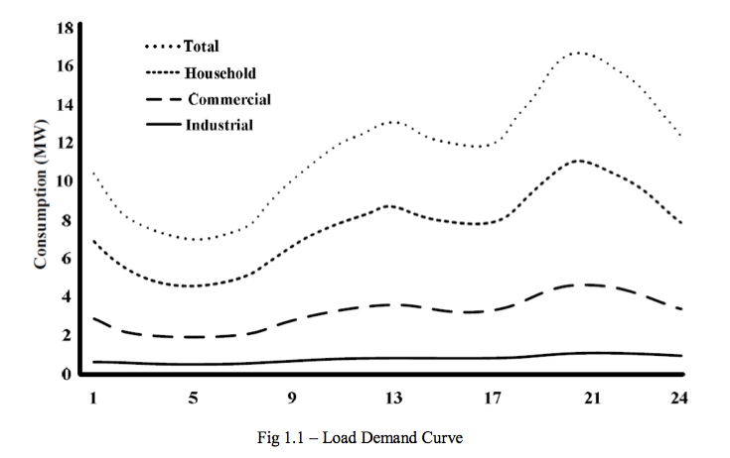

Figure 1.1: Load Demand Curve

# 1.3. BDC advantages

They are suitable for peak shaving application. For this application, the batteries act as energy storage units. Energy is stored in the batteries during night time when the cost of electricity is at its lowest. During peak hours, unused energy are drawn from them to put power back to the grid. With this scheme, Electric Vehicles owners could produce revenue. They charge their batteries while electricity is cheap, and use them to put power back to the grid during peak hours. Utilities could also benefit from this by having increased system flexibility. They could use this as energy storage for intermittent renewable energy sources such as wind and solar. BDC is also suitable for regulating frequency fluctuations caused by system imbalances. Through bidirectional converters, regulation is made possible by allowing the grid to absorb/release small quantities of energy from/to the batteries.

There are various advantages offered by DC grids to end-consumers, utilities and society, such as: improved energy efficiency, minimized overall energy consumption, reduced greenhouse gases and pollutant emissions, improved service quality and reliability, cost efficient electricity infrastructure replacement.

Technical challenges linked with the operation and controls of DC grids are immense. Ensuring stable operation during network disturbances, maintaining stability and power quality in the islanding mode of operation necessitates the improvement of sophisticated control strategies for DC grid’s inverters in order to provide stable frequency and voltage in the presence of arbitrarily varying loads. In light of these, the DC grid concept has stimulated many researchers and attracted the attention of governmental organizations in Europe, USA and Japan. Nevertheless, there are various technical issues associated with the integration and operation of DC grids.

# 1.4 Overall Bidirectional converter block diagram

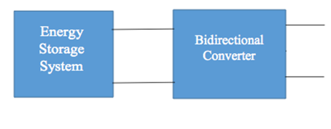

AC Grid Single Phase

Figure 1.2: Grid Power System

**Chapter – 2**

Methodology

In recent years, due to the growing concern over energy shortage and environmental pollution, the concepts of distributed generation (DG), and dc-ac based hybrid power systems have become progressively more popular with the decreasing costs of various clean renewable energy sources. Under small-scale power distribution system, such as house, commercial buildings, bi-directional single-phase PWM converters perform as key components to fulfill the following modes of operation.

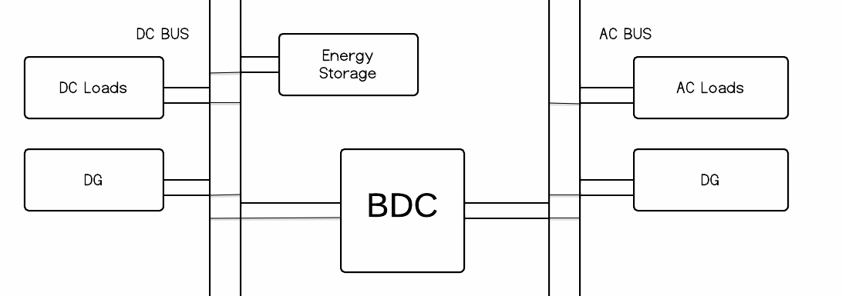

Figure 2.1: Flow Diagram

Figure 2.2: BDC Modes

Grid-tied

Inverter Mode

Grid-tied

Charger Mode

Grid-tied

Rectifier Mode

Stand Alone Inverter Mode

# 2.1 Stand Alone Inverter Mode

Stand-alone inverter or off-grid inverter is designed for remote stand-alone application or off-grid power system with battery backup where the inverter draws its power from batteries (energy storage system) and converts to AC power. Stand-alone inverters provide variety of size and output waveform depending on applications. For the best output, the pure sine inverter is required. It suits for solar home system, rural electrification, village electrification in remote area where the utility grid is not available.

When the grid is lost, the converter regulates the ac bus voltage and frequencies feeding the ac loads while the renewable energy sources or energy storage on the dc side to provide power. The ac side renewable energy resources would act as current sources.

# 2.2 Grid Tied Inverter Mode

|  |
| --- |
| Grid connected inverter or grid tie inverter is designed specifically for grid connected application using either battery backup or dc grid system. Grid connected inverter or grid tie inverter converts DC power to AC power to supply to electrical appliances and sell excess power back to utility grid depending on load demand. With a range of sizes available, we provide grid tie inverter to suit your needs, from small residential solar system to large commercial solar system on dc side. It can reduce energy consumption and save the utility cost, while maintaining the ability to use the renewable energy source during power outage. |

When the grid is connected, the converter acts as a current source injecting or sinking power from the grid to balance the power flow between the dc and ac subsystems, while one of the dc resources regulates the dc bus voltage.

# 2.3 Grid Tied Rectifier Mode

|  |  |  |  |
| --- | --- | --- | --- |
| Grid tied rectifier mode is designed for residential, commercial and industry applications depending on DC loads. For residential use it can be electrical vehicle charging etc. This mode can be widely used for commercial purposes for running dc motors in industries. When the grid is present, the converter regulates the dc bus voltage to sustain the dc loads. | | | |
|  |  |  |  |

# 2.4 Grid Tied Charger Mode

When the grid is present, the converter charges the energy storage elements, such as batteries.

By applying the modeling methodology of semi-conductor switches, the switching, average and small signal models of the converter are derived under different modes of operation.

**Chapter – 3**

Hardware Implementation of Single Phase Bidirectional Converter

# 3.1 Power Circuit

Power circuit was fabricated using MOSFETs (IRF460) as basic switching devices. As discussed in previous chapters, standard H-bridge has been used. MOSFETs have been fitted on a module which receives the TTL gate pulses from pulse generator circuit and various components as discussed below performs the task of protection and isolation of devices.

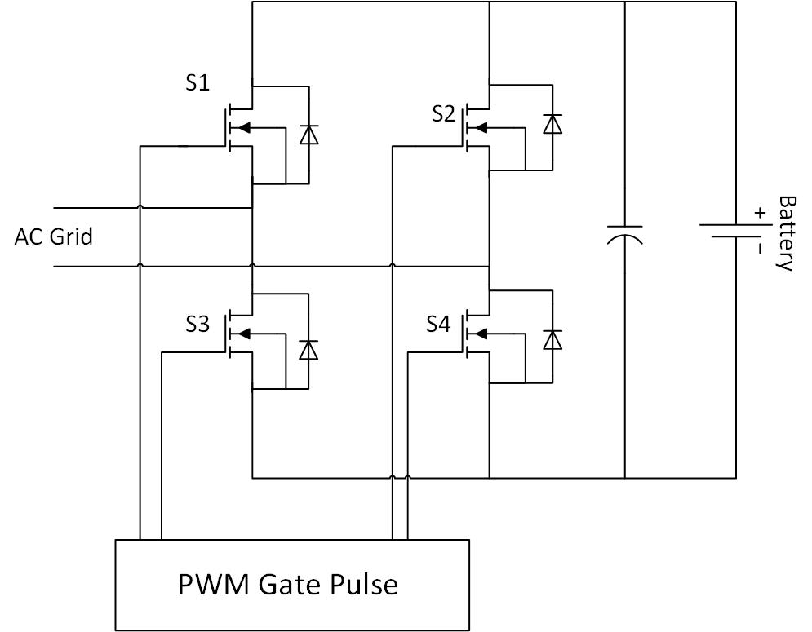

Figure 3.1: Power Circuit for AC-DC Bidirectional Converter

## 3.1.1 Snubber Circuit

It protects semiconductor devices by:

* Limiting device voltages during turn-off transients.
* Limiting device currents during turn-on transients.
* Limiting rate of rise of currents through semiconductor device at device turn-on.
* Limiting rate of rise of voltages through semiconductor device at device turn-off.
* Shaping the switching trajectory of the device as it turns on/off.



Figure 3.2: Snubber Circuit

Values of capacitance to be used can be calculated as under:

$$C_{s}=\frac{{I_{max}*T}_{min}^{off}}{V_{in}}=\frac{27*168*{10}^{-9}}{24}=0.1μF$$

## 3.1.2 Pulse Amplification and Isolation Circuit

Pulse amplification and isolation circuits first isolate the pulses coming from TTL sources from the power circuits and then pulses are amplified. Whole process of amplifying and isolation is carried out by MCT2E along with NPN transistors and separate DC supply created using standard 12-0-12 transformer and voltage regulator-7812. Separate DC supply is must for each module as the pulses have to be given with respect to the source of each MOSFET, hence we need separate ref. point for each pulse.

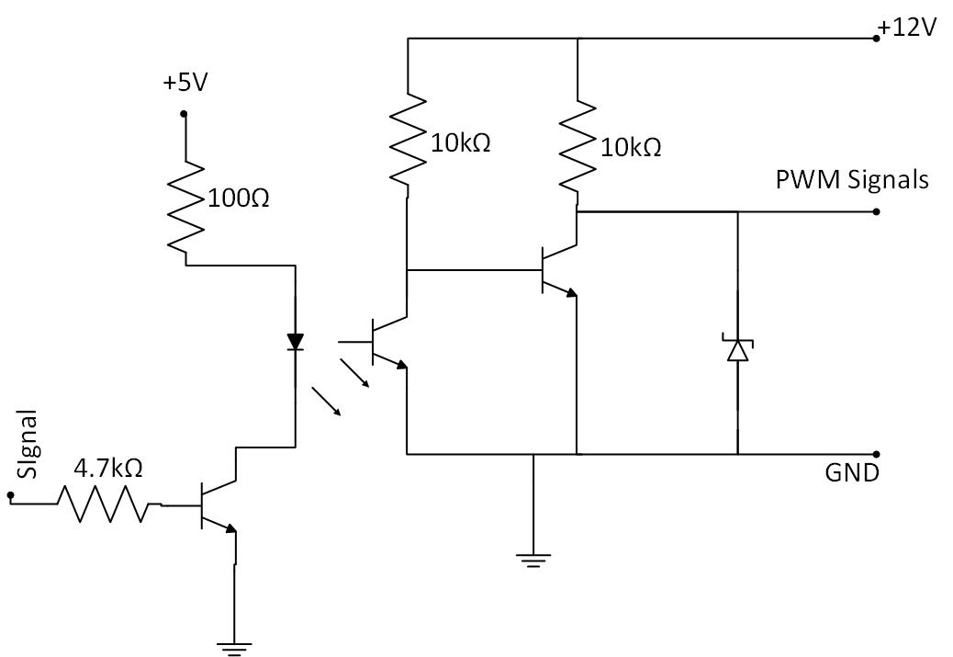

Figure 3.3: Pulse Amplification Circuit schematic and its actual implementation

# 3.2 Control Circuits

Control Circuit has been made up of different components fabricated as separate PCB’s. Each PCB is a unique module in itself which performs a unique function. Various Components of control circuit have been discussed as under:

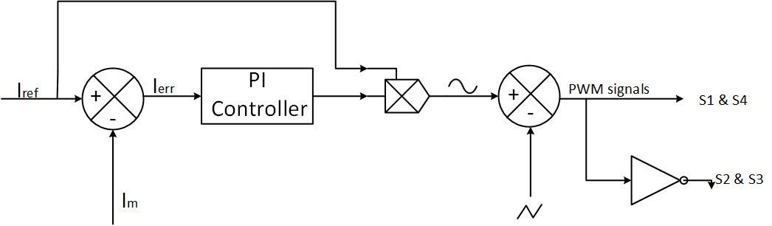

Figure 3.4: Control Circuit

## 3.2.1 Voltage sensing circuit

Voltage sensing was performed using a standard AD-202 circuit as shown in figure below.AD-202 performs the task of isolation and stepping down of input signal. It was ensured that peak of voltage reaching the input terminals of AD202 is less than 5 volts. This was ensured by using a stepping down circuit using resistors.

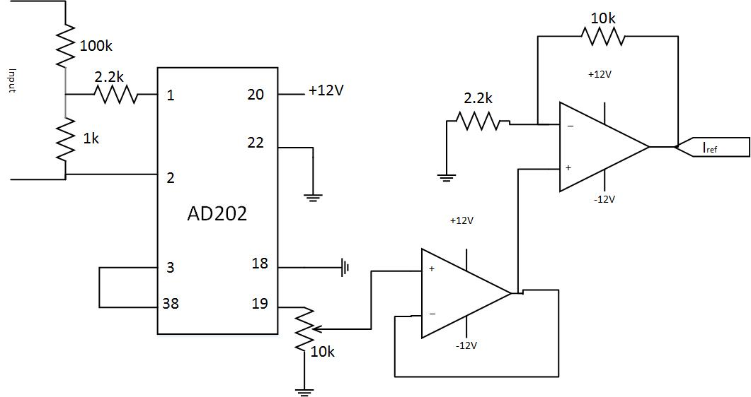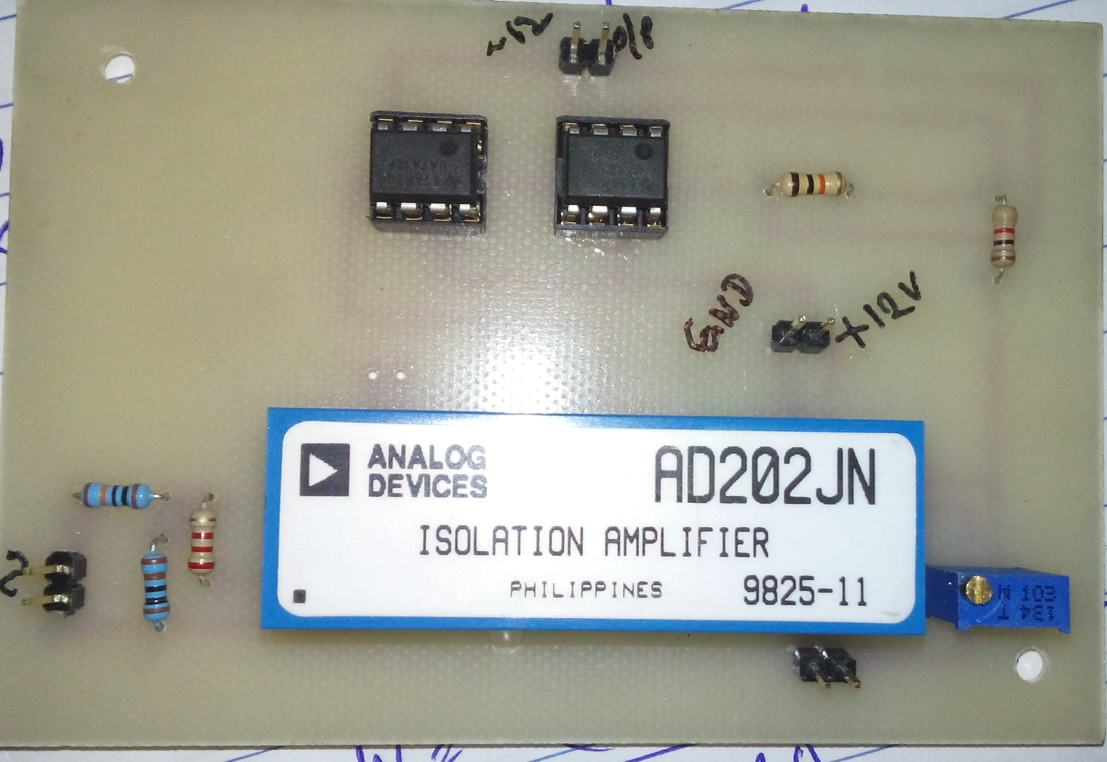



Figure 3.5: Voltage Sensing Module

## 3.2.2 SPWM Pulses Generation Module

This module has the function of generating uses following sub-modules:

* Triangular wave generation.
* SPWM core circuit

### 3.2.2.1 Triangular Wave Generator

Since the required frequency has to be greater than 18 KHz as per IEEE standards as mentioned in previous chapters, a minimum slew rate of 50V/us is required. Hence the op-amp 741 is used and a standard triangular wave generation circuit was followed to obtain a unity triangular wave of frequency 25 KHz. The circuit, schematic and output has been shown in below figures.

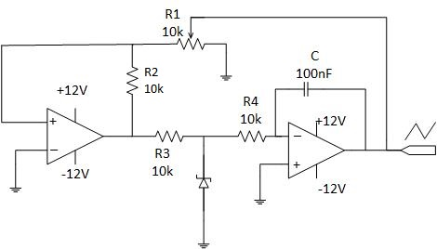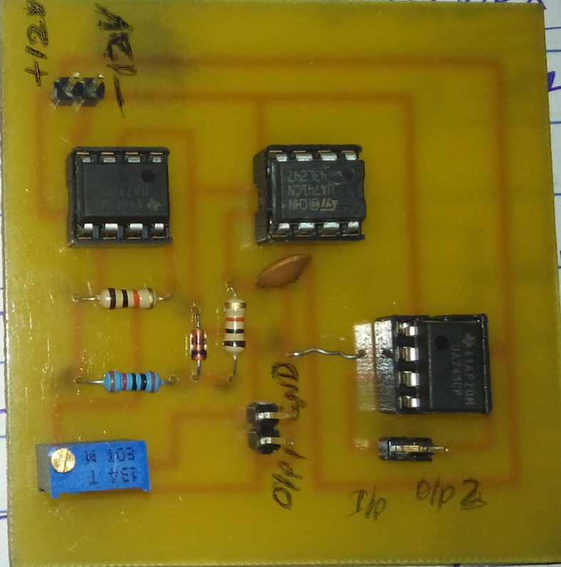

Figure 3.6: Triangular Wave Generator



Figure 3.7: Triangular Wave output waveform

$$Peak to peak voltage output=(2*R_{4}/R_{1})*V_{sat}$$

$$Frequency=\frac{R_{1}}{R_{4}*4*\left(R_{2}+R_{3}\right)*C}$$

### 3.2.2.2 SPWM Core Circuit

It compares the ref. and carrier signal to produce a PWM Signals as per the switching strategy. The SPWM waveform has harmonics of several orders in the phase voltage waveform , the dominant ones are the fundamental and other of order of n and n±2 where $n=f_{c}/f_{m}$. With the method of Selective Harmonic Elimination, only selected harmonics are eliminated with the smallest number of switching. For a single phase-SPWM waveform with odd and half wave symmetry and n chops per cycle.



Figure 3.8: SPWM Control Strategy

We know that in SPWM control mode

$$mVdc= \sqrt{2}Vp1$$

Where

**m:** modulation Index

**Vdc:** DC voltage

**Vp1:** Fundamental RMS voltage

As power is fed at UPF, we can write that

$Vp1 cos δ=Vg$**and $Vp1 sin δ = IX$**

$m=\frac{\sqrt{2}V_{g}}{V_{dc}\cos{δ}}$

⇨ 

Also ,

$$Ppv = Pg= VdcIdc = VgIg$$

Where

$V_{g}$ and $I_{g}$ are RMS value of grid voltage and current.

$$Ig=\frac{V_{p}\sin{δ}}{X}$$

On solving above equations, we find that

$$m=\frac{\sqrt{2V_{g}^{2}+{(\frac{PX}{V_{g}})}^{2}}}{V_{dc}}$$

Thus, by fixing $V_{dc}$, X and P we can calculate the modulation Index. Also, X is fixed by design constraints; P and $V_{dc}$ are fixed by the characteristics of batteries.

Advantages of SPWM:

* Low power consumption.
* High energy efficient upto 90%.
* High power handling capability.
* No temperature variation-and ageing-caused drifting or degradation in linearity.
* Easy to implement and control.
* Compatible with today’s digital microprocessors

Disadvantages of SPWM:

* Attenuation of the wanted fundamental component of the waveform.
* Drastically increased switching frequencies that leads to greater stresses on associated switching devices and therefore de-rating of those devices.
* Generation of high-frequency harmonic components.

## 3.2.3 Current Sensing Circuit

Current sensing circuit is fabricated using Hall Effect sensor, buffer and amplifier. The hall sensor is measuring the current by using the magnetic field around the conductor where the current is flowing through. The sensors are mostly internal compensated and support frequencies up to 200 kHz with almost to losses. Therefore the hall sensor “HTP 25” will be used to measure the current in the test setup. This current transducer is able to measure currents up to 200A and 100 kHz with an accuracy of 90%.

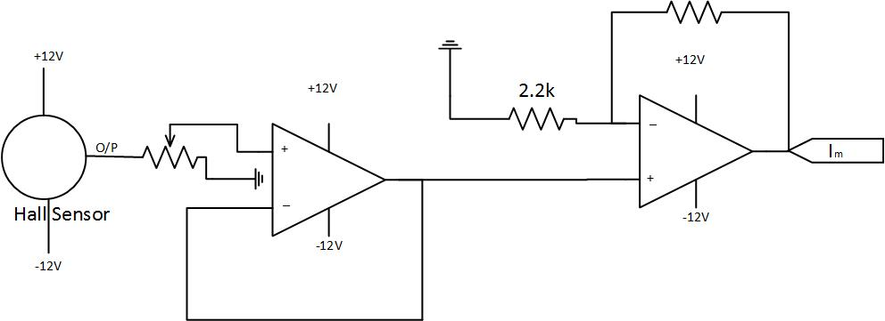

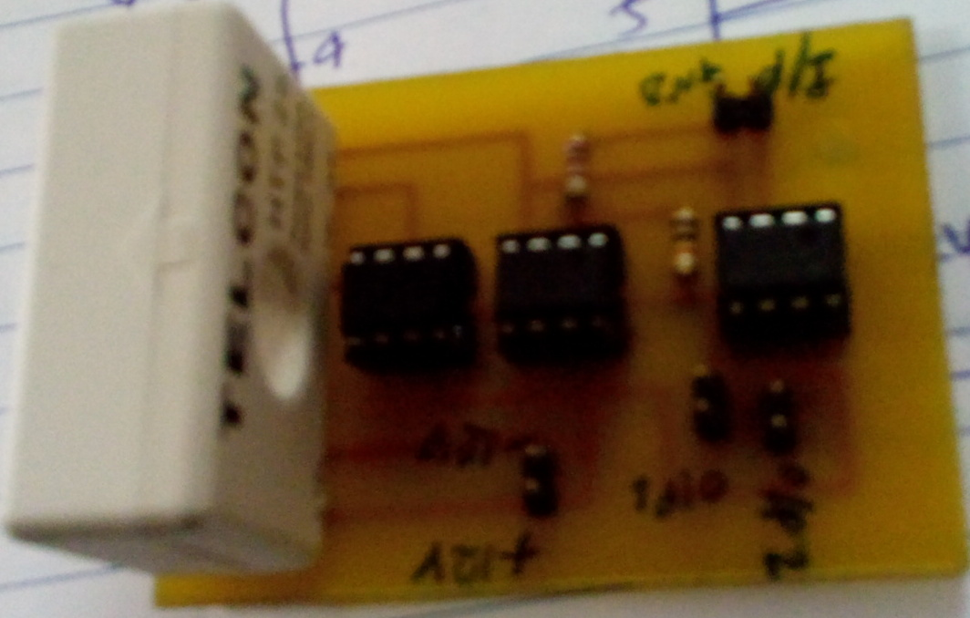

Figure 3.9: Current Sensing Circuit

## 3.2.4 PI Controller Circuit (Analog)

A proportional-integral-derivative controller (PID controller) is a [control loop](http://en.wikipedia.org/wiki/Control_loop) [feedback mechanism](http://en.wikipedia.org/wiki/Feedback_mechanism) ([controller](http://en.wikipedia.org/wiki/Controller_(control_theory))) widely used in [industrial control systems](http://en.wikipedia.org/wiki/Industrial_control_system) ([Programmable Logic Controllers](http://en.wikipedia.org/wiki/Programmable_Logic_Controllers), [SCADA](http://en.wikipedia.org/wiki/SCADA) systems, [Remote Terminal Units](http://en.wikipedia.org/wiki/Remote_Terminal_Unit) etc). A PID controller calculates an "error" value as the difference between a measured [process variable](http://en.wikipedia.org/wiki/Process_variable) and a desired [setpoint](http://en.wikipedia.org/wiki/Setpoint_(control_system)" \o "Setpoint (control system)). The controller attempts to minimize the error in outputs by adjusting the process control inputs.

Some applications may require using only one or two actions to provide the appropriate system control. This is achieved by setting the other parameters to zero. A PID controller will be called a PI, PD, P or I controller in the absence of the respective control actions. PI controllers are fairly common, since derivative action is sensitive to measurement noise, whereas the absence of an integral term may prevent the system from reaching its target value due to the control action. 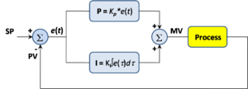

Figure 3.10: PI Controller Block Diagram

A **PI Controller** (proportional-integral controller) is a special case of the PID controller in which the derivative (D) of the error is not used.

The controller output is given by

$$K_{P}∆+K_{I}\int{∆}dt$$

where $∆$  is the error or deviation of actual measured value (***PV***) from the set point (***SP***).

.

$$∆=SP-PV$$

A PI controller can be modelled easily in software such as [Simulink](http://en.wikipedia.org/wiki/Simulink) using a "flow chart" box involving [Laplace](http://en.wikipedia.org/wiki/Laplace_transform) operators:

$$C=\frac{G\left(1+τs\right)}{τs}$$

Where

$G= K_{P}= proportional gain$

$\frac{G}{τ}=K_{I}= integral gain$

Setting a value for  is often a trade-off between decreasing overshoot and increasing settling time.

The lack of derivative action may make the system steadier in the steady state in the case of noisy data. This is because derivative action is more sensitive to higher-frequency terms in the inputs.

Without derivative action, a PI-controlled system is less responsive to real (non-noise) and relatively fast alterations in state and so the system will be slower to reach set point and slower to respond to perturbations than a well-tuned PID system may be.

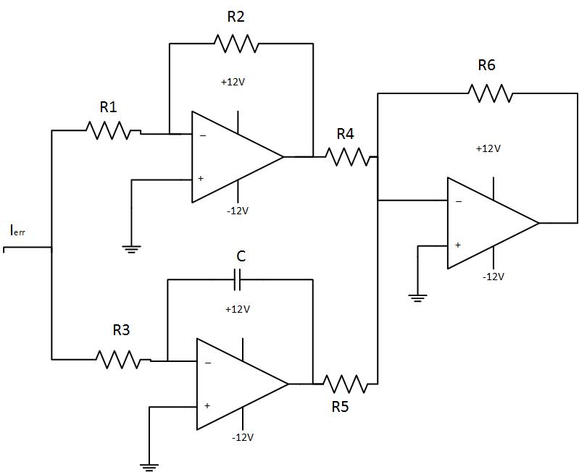

Figure 3.11: PI Controller Circuit

# 3.3 Power Supplies

Here is the standard dual power supply using the Positive and Negative Voltage regulator ICs. It can give +12 volt and – 12 volt DC with a common ground. This power supply is ideal to power amplifier circuits that require well regulated dual power supply. It can give 1 ampere current to the circuit. 14-0-14 volt 1 Ampere step down transformer is used to drop 230 volt AC to 14 volt DC which is then rectified using the standard full wave bridge rectifier comprising D1 through D4.Smoothing capacitors C1 and C2 remove the ripples from low volt AC. Two regulator ICs are used to generate + 12 volt and – 12 volt DC. IC1 is 7812 positive regulator giving +12 volt regulated output.IC2 is 7912 negative regulator and its pins are slightly different from 7812. See the connection in the diagram. Regulated outputs from the regulator ICs are available from pin 3 which can be used to power the circuit. Capacitors (C3 and C4) act as noise filters to give clean DC.

7805 is a 5V fixed three terminal positive voltage regulator IC. The IC has features such as safe operating area protection, thermal shut down, internal current limiting which makes the IC very rugged. Output currents up to 1A can be drawn from the IC provided that there is a proper heat sink. A 9V transformer steps down the main voltage, 1A Bridge rectifies it and capacitor C1 filters it and 7805 regulates it to produce a steady 5V DC. The circuit schematic is given below.



Figure 3.12: $\underline{+}$ 12V Supply Circuit schematic [7][12]



Figure 3.13: $\underline{+}$ 5V Supply schematic [13]

**Chapter – 4**

Experimental Setup and Results

Whole project was setup as per the strategies discussed in previous chapters. A connection diagram of overall project has been shown as under.

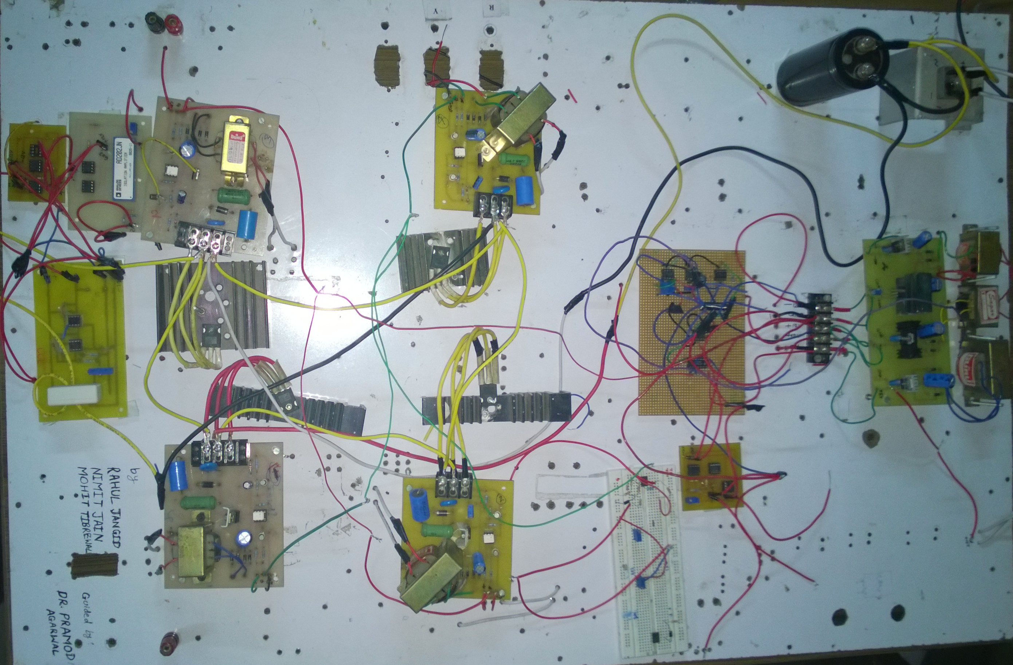

Figure 4.1: Connection Diagram

# 4.1 Hardware Design



Figure 4.2: a) Unity rectifier, b) Unity inverter, c) Purely Capacitive, d) Purely Inductive [8]

# 4.2 Hardware Layout

The proposed power electronic converter in the previous chapter is connected between the AC- grid and the battery-bus (DC-grid). Therefore the semiconductors, gate drivers and cooling have to be designed according the specifications of these connected systems. Calculations have to be carried out on component ratings, gate drivers and thermal requirements, the outcomes have to be optimized in cost, weight and efficiency as stated. By summarizing chapter 2, the following hardware requirements can be presented:

* Topology is full bridge Single phase converter with four active switches.
* Nominal phase current is 10amps.
* The system has to be able to operate at 2.2 $I_{nom}$ in order to withstand high currents in case of faults.
* Nominal phase-to-neutral voltage is 230 $V_{rms}$.
* The nominal operating frequency is 50 Hz.

# 4.3 Gate driver

A gate driver is a [power amplifier](http://en.wikipedia.org/wiki/Power_amplifier) that accepts a low-power input from a controller [IC](http://en.wikipedia.org/wiki/Integrated_circuit) and produces a high-current drive input for the gate of a high-power transistor such as an [IGBT](http://en.wikipedia.org/wiki/IGBT) or [power MOSFET](http://en.wikipedia.org/wiki/Power_MOSFET). Gate drivers can be provided either on-chip or as a discrete module. In essence, a gate driver consists of a [level shifter](http://en.wikipedia.org/wiki/Comparator#Level_shifter) in combination with an [amplifier](http://en.wikipedia.org/wiki/Amplifier).

# 4.4 Test Setup

Before a prototype of the power electronic system can be made many aspects have to be investigated in practice. Therefore a test setup is developed to analyze the following things in more detail:

* Hardware component operating performance.
* Sensors output signals.
* MOSFET operation.
* PWM methods.

By doing these measurements, the final design can be improved and the best PWM solution can be applied. Figure xxxxx shows the test setup of the power electronic converter which is connected to the synchronous machine.

# 4.5 Control Strategy (Carrier based Modulation)

Carrier based modulation is a voltage control method where a phase-to-phase voltage is generated based on a comparison between a carrier and a reference waveform. The carrier can be triangular or saw-tooth shaped, while the reference voltage is purely or edited sinusoidal. These two waveforms are generated and compared by a digital or an analog circuit and results in a PWM waveform. The choice between analog and digital depends on the application, but nowadays a digital controller is preferred because it is also able to handle other tasks (logging, control, communication) in its application.

## 4.5.1 Carrier Waveform

As mentioned above, the carrier can be saw-tooth or triangular shaped. During operation the reference voltage is compared to the carrier voltage, when the reference is higher than the carrier a positive pulse is generated and otherwise a zero pulse is the result.



Figure 4.3: PWM with Saw Tooth and triangular carrier [9]

For the triangular carrier only the trailing edge of the pulse varies when the value of the modulation index changes, in contrast to the triangular carrier, both sides of the switched output pulse from the phase leg are modulated which results in a symmetrical waveform. The advantage of the symmetrical waveform is that the odd harmonic sideband components around odd multiples of the carrier fundamental and even harmonic sideband components around even multiples of the carrier fundamental are eliminated [23]. Due to the bad harmonic performance of the saw-tooth carrier, only the triangle carrier will be used in this chapter.

Looking at one period of the reference voltage, the phase voltage with respect to the neutral (n) looks like in figure 4.4 (a):

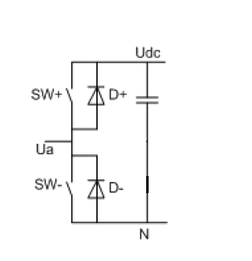

Figure 4.4: a) Carrier based PWM generation b) Switching leg

The relationship between the reference and carrier frequency is called “frequency modulation ratio” and is defined as:

$$mf=\frac{f_{s}}{f_{1}}$$

Where $f_{s}$ is the triangular carrier frequency and $f_{1}$ is the fundamental frequency. The mf should be an odd integer in order to achieve an odd symmetry waveform and half-wave symmetry with the time origin. Therefore only odd harmonics are present and the even harmonics disappear from the phase to star point voltage ($U_{a0}$).

## 4.5.2 Reference Waveform

The output of the carrier based modulator can be controlled by changing the reference waveform which is compared with the carrier waveform. A sinusoidal fundamental output voltage can be achieved by using a sinusoidal reference. Output frequency can be determined and the effective phase-to-phase voltage amplitude can be controlled by changing the amplitude of the reference voltage, also called the modulation index (ma):

$$ma = Û_{ref} /Û_{tri}$$

Where $Û_{ref}$ is the amplitude of the reference voltage, and $Û_{tri}$ is the amplitude of the triangular voltage. Since the amplitude of the triangular carrier is 1, ma should be kept lower or equal than 1 to avoid over modulation and undesirable harmonics in the system [10][11].

The characteristics of carrier modulation can be summarized as follows:

* Simple implementation (digital or analog).
* Fixed switching frequency.
* Losses and THD are directly related to the switching frequency.

Due to limited hardware in the test facility the measurements are carried out under the following conditions:

* DC bus voltage of 220V
* Maximum frequency 50Hz
* Closed loop control

# 4.6 THD and efficiency

Total harmonic distortion and converter losses were two important aspects in the decision of the PWM and control method. Based on these aspects, the carrier based modulation combined with the field oriented control method is chosen.

The proposed solution is implemented and total harmonic distortion and efficiency are measured. The measurements are done under the following conditions:

* Fundamental frequency: 50Hz
* DC bus voltage: 220V
* Closed loop control
* Inverter operation

As expected is the converter efficiency decreasing when higher switching frequencies are used and the dips in the THD are at odd frequency ratios. However, the losses are higher than expected and also the harmonic is much higher. These differences can occur because of the following reasons:

* Unbalanced load
* Variations on the DC bus
* Current offset
* Incorrect PWM pattern

# 4.7 Expected Results

## 4.7.1 Stand-alone Inverter Mode



Figure 4.5: top) PWN Phase, mid) Phase-to-phase Voltage, bottom) Phase-to-neutral Voltage

# 4.8 Results

## 4.8.1 Stand-alone Inverter Mode



Figure 4.6: Voltage and current waveforms at inverter terminals

## 4.8.2 PWM Waveform

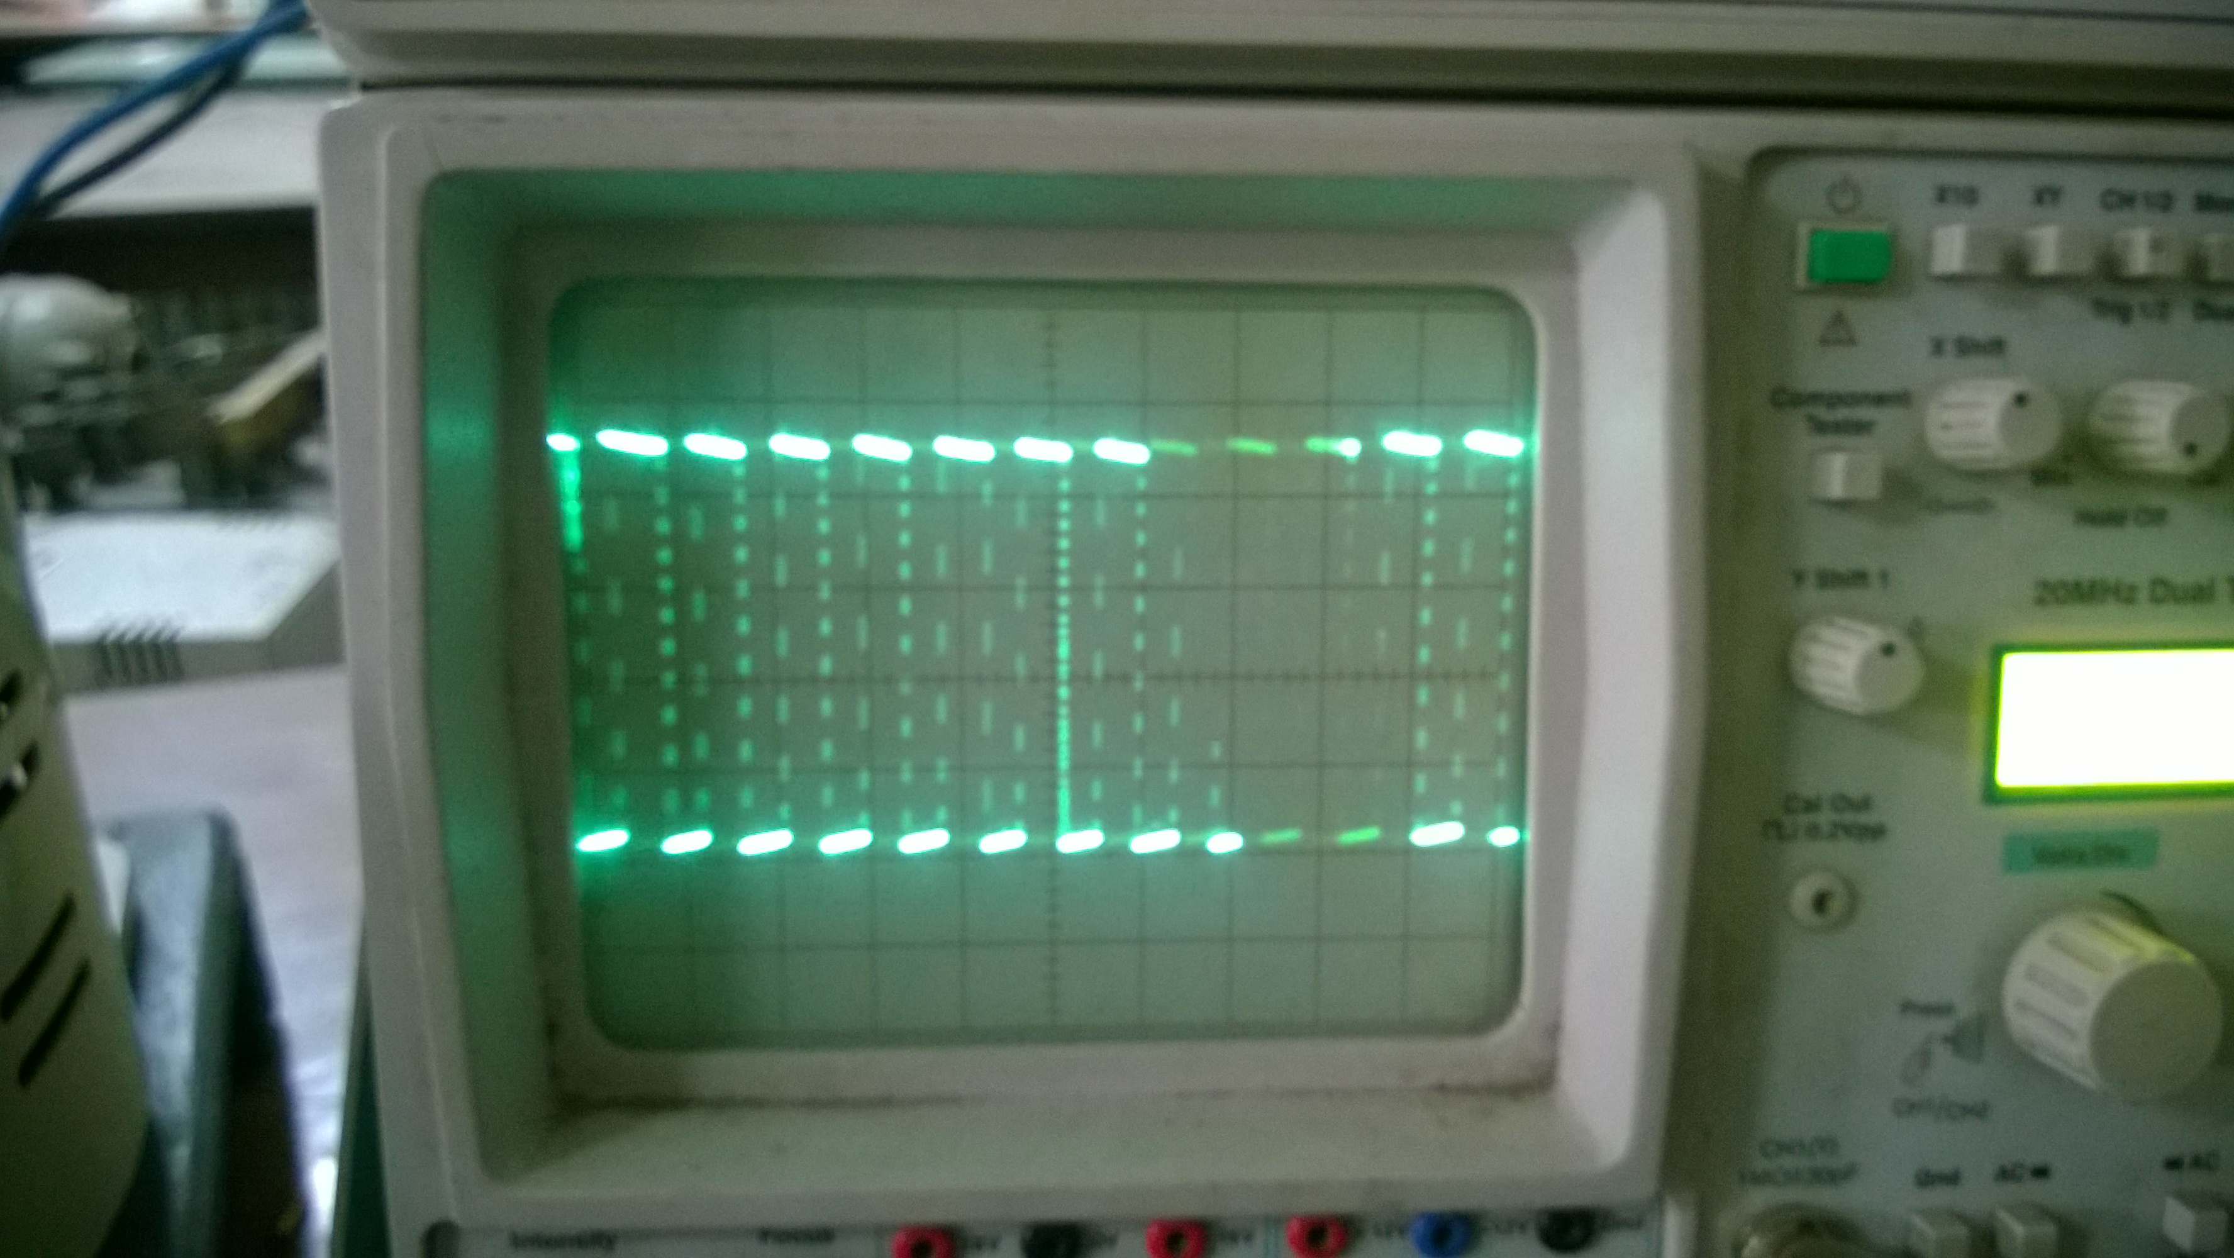

Figure 4.7: Output PWM Waveform

## 4.8.3 Voltage Sensor Module

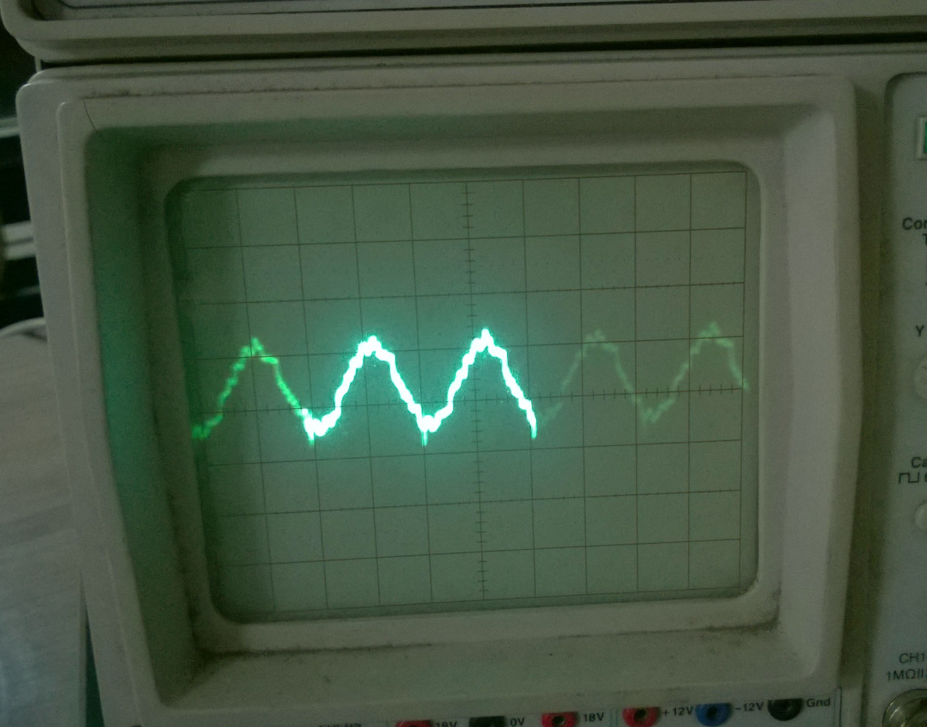

Figure 4.8: Voltage Sensor Output

**Chapter – 5**

Conclusion and Future Scope

# 5.1 Contribution and Conclusion

This project deals with the design and implementation of a bi-directional full bridge power electronic converter. The converter is able to rectify the voltage in generator operation and act as inverter during starting operation. The discussed solution is optimized in cost, controllability, efficiency and weight.

The hardware design of the full bridge converter consists of different components which are optimized according operating characteristics, price, efficiency and robustness:

* MOSFETs are used for the four switches in the design since they are available in the required high power ratings, provide relative low switching and conduction losses and support switching frequencies up to 200 kHz.
* Opto-couplers are the best solution to provide electrical isolation between the control circuit and gate drivers since they are economic, compact and have a good performance. However, optical cables are used in the test setup because they are less sensitive for EMI compared to opto-couplers, but are also more expensive.
* Hall sensors are used to measure the current. They provide an efficient and accurate current measurement with high electrical isolation, bandwidth and high frequency.

# 5.2 Future Work

This single-phase converter can be easily extended to a three phase converter by tripling the two-leg configuration and connecting the neutral points together. This will open the possibilities of the following:

* Integration of DC microgrids to improve efficiency of energy storage and generation systems. For instance,a dedicated DC grid for electric vehicles in a city which also acts as energy storage system for the AC grid.
* Power sharing between isolated micro-grids through DC interconnection.
* Development of reliable, high quality grid may be feasible for small isolated industrial plants with both PV systems and wind turbine generator as the major power supply.
* The implemented software is limited to closed loop control. However, to control the power electronic converter, the proposed field oriented control loop needs to be implemented and tested.
* Another aspect are the opto-couplers. They are more economic and compact compared to the conventional options like optic fiber cables. The switching behavior and requirements of these opto-couplers have to be investigated and a redesign has to be made in order to achieve an even more compact and robust solution.

**References**

[1]. Rashid. M.H, “Power Electronics circuits devices and applications”, PHI 3rd edition, 2004 edition, New Delhi.

[2]. Bimbhra .P.S "Power Electronics" Khanna Publishers, New Delhi, 2003. 4th Edition

[3]. S. Bose, Y. Liu, K. Bahei-Eldin, J.de Bedout, and M. Adamiak, “Tie line Controls in DC grid Applications,” in iREP Symposium Bulk Power System Dynamics and Control VII, Revitalizing Operational Reliability, pp. 1-9, Aug. 2007.

[4] R.H.Lasseter, “DC grids,”inProc.IEEE-PES’02, pp.305-308, 2002.

[5] Michael Angelo Pedraza and Ted Spooner, “A Survey of Techniques Used to Control  DC grid Generation and Storage during Island Operation,” in AUPEC, 2006.

[6] F. D. Kanellos, A. I. Tsouchnikas, and N. D. Hatziargyriou, “DC grid Simulation during Grid-Connected and Islanded Mode of Operation,” in Int. Conf. Power Systems Transients (IPST’05), June. 2005.

[7] Ming Li, Dong Dai & Xikui Ma, *"Slow-Scale and Fast-Scale Instabilities in Voltage- Mode Controlled Full-Bridge Inverter"* Journal: Circuits Systems and Signal Processing - CIRC SYST SIGNAL PROCESS , vol. 27, no. 6, pp. 811-831, 2008.

[8] J. Dixon, “Three-Phase controlled rectifiers”, Pontifcia Universidad Catolica de Chile, Chile.

[9] D. C. Rus, N. S. Preda, I. I. Incze, M. Imecs, Cs. Szabo, “Comparative Analysis of PWM Techniques: Simulation and DSP Implementation”.

[10] K. Zhou, D. Wang, “Relationship between space-vector modulation and three-phase carrier based PWM: A comprehensive analysis”

[11] N. Mohan, T. M. Undeland, W. P. Robbins (2003). Power Electronics. 3rd ed. Hoboken: Wiley. P225.

[12] http://electroschematics.com

[13] www.circuittoday.com

[14] www.wikipedia.org

**APPENDIX-A**

A.1 IRFP-460 MOSFET specifications

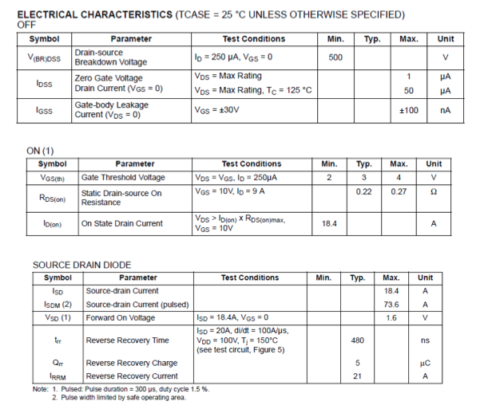

A.2 AD-202, Isolation Amplifier Specifications

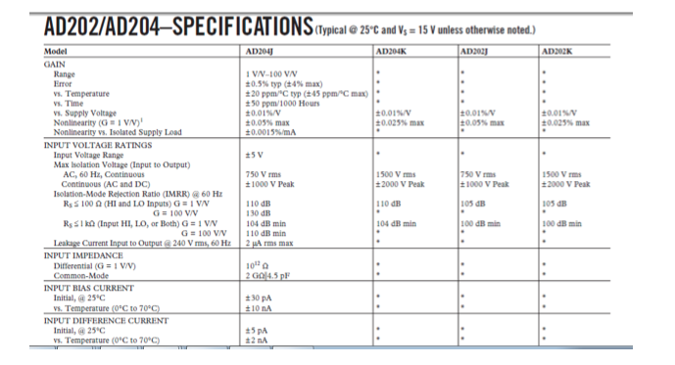

A.3 AD-633, Multiplier Specifications



**APPENDIX-B**

B.1 Voltage sensor PCB

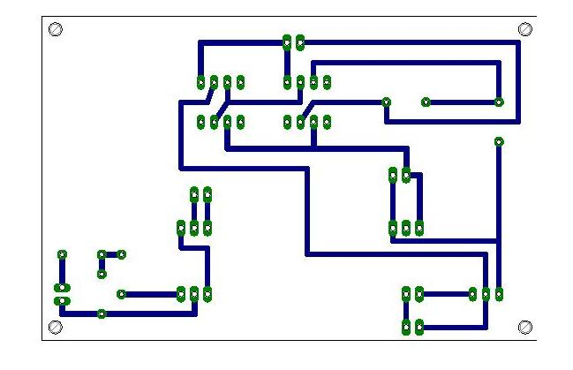

B.2 Current sensor PCB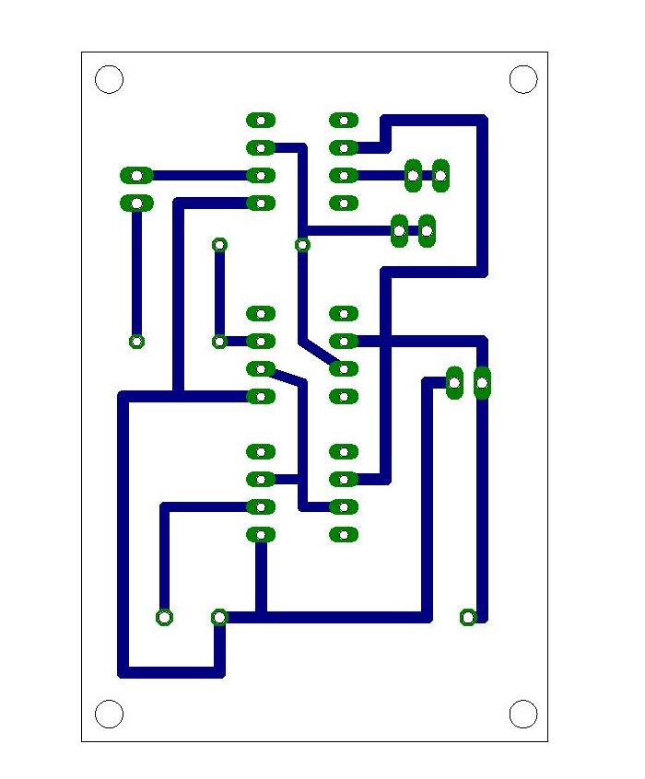

B.3 PI controller PCB

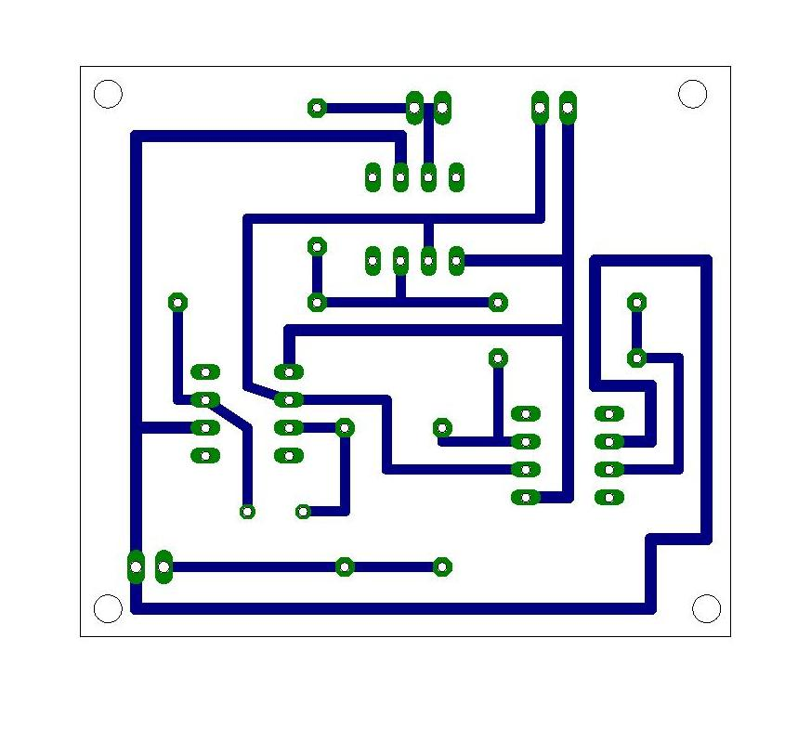

B.4 Triangular Wave Generator PCB

